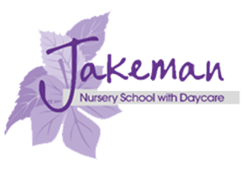
Jakeman Nursery School

Every Wednesday we are offering a FREE stay and play session for children aged 0-3 years old and a parent/carer/adult family member.
Each session will be themed with a different learning experience.

There will be advice and support for families around transition into nursery, special educational needs and sign posting to support other agencies.

We are also able to check eligibility for FREE nursery provision for 2,3 and 4yr olds.

Come and join us!

WHEN: Starts on Wednesday 26th April 2023
(and every Wednesday for the rest of the summer term)
TIME: 9:00am-10:30am
ENTRY: Free
We look forward to meeting you

